1 Stage - GUI Design

Screen 1. Menu.

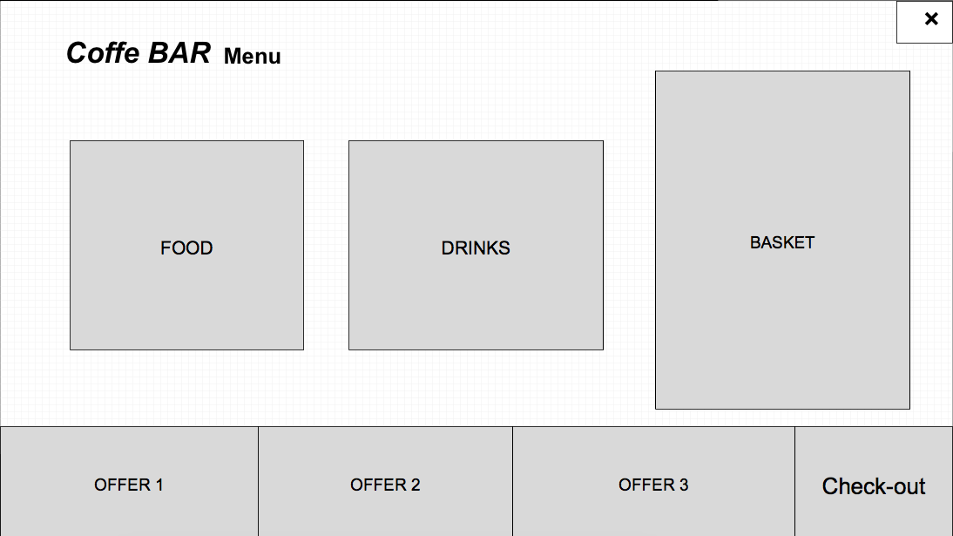

The first thing we find is the name of the Coffee.

1. Food Button. We will put the action that if you click another screen will appear/change, with the list of food items (see next image).
2. Drinks Button. Works as the Food Button.
3. Basket. Not a button with an action, only shows all the items selected + the quantity. Maybe we can include the total prize too.
4. Offer Buttons. In the bottom of the screen we find the offers. If you click in one/each of them, the description of the offer will change. (Offer1 will change to 🡪 meal deal: sandwich + hot drink + snack, etc).
5. Check-out button. Changes to Check-out Screen.
6. Close Button. Closes the app.

Screen 2.1. Food.

1. First thing we see is the name of the screen: Food.
2. Go Back Button. Redirects/changes screen to the previous one (screen 1).
3. Menu: description of food items. It is a descriptive but also there will be action buttons: you can click in each item to have a description. This description will appear on the left of the screen.
4. Quantity: you can select how many items you want.
5. Prize. Is something fixed, just descriptive.
6. Offer buttons. Same action as the previous screen. Click to show info.
7. Close Button. Closes the app.

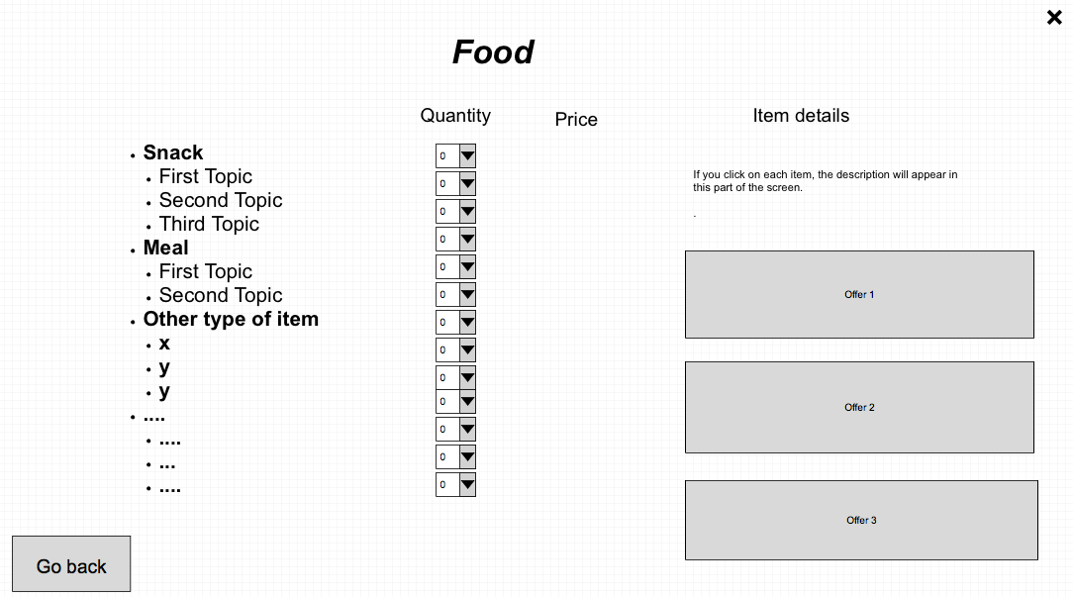

Screen 2.2. Drinks:

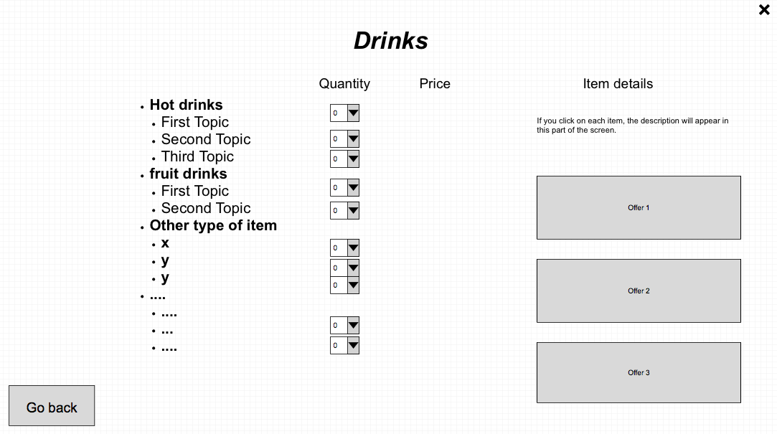

1. First thing we see is the name of the screen: Drinls.
2. Go Back Button. Redirects/changes screen to the previous one (screen 1).
3. Menu: description of drinks items. It is a descriptive but also there will be action buttons: you can click in each item to have a description. This description will appear on the left of the screen.
4. Quantity: you can select how many items you want.
5. Prize. Is something fixed, just descriptive.
6. Offer buttons. Same action as the previous screen. Click to show info.
7. Close Button. Closes the app.

Screen 3. Check-out.

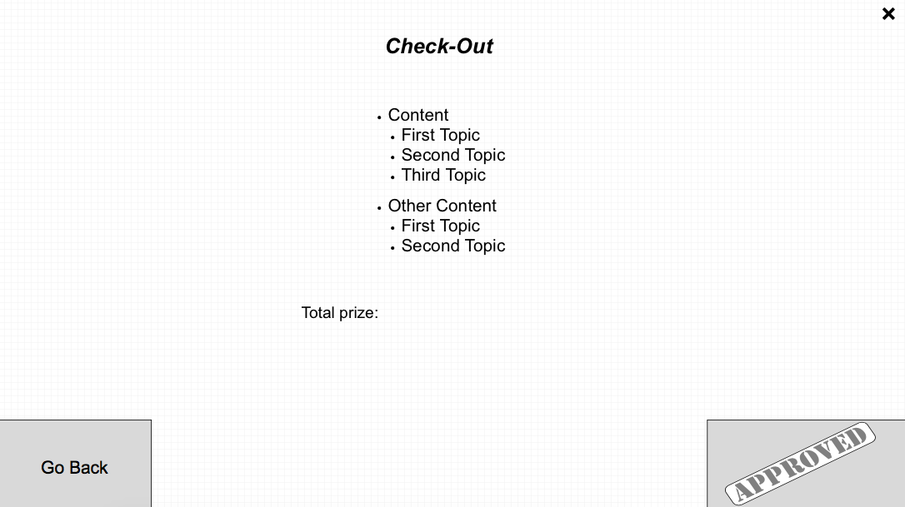

1. List of items to be ordered with total prize (offers included). Just descriptive.
2. Go Back button. Goes back to screen 1.
3. Approved. Ok. Button. Processes order. This button also will “print” a text file with the items purchased. + Changes screen to final screen.
4. Close Button. Closes the app.

Screen 4.

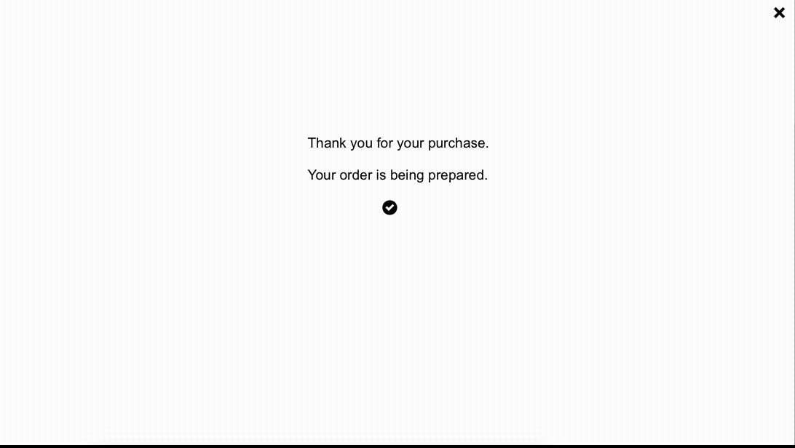

1. Final screen. Descriptive. Only button to press is the close button: finishes app.